Северна Македонија
П.Фах 560, 1001 Скопје
Партизански одреди 24,
ДГКМ
MASE
ДРУШТВО НА
ГРАДЕЖНИТЕ
КОНСТРУКТОРИ НА
МАКЕДОНИЈА
MACEDONIAN
ASSOCIATION OF
STRUCTURAL
ENGINEERS
Partizanski odredi 24,
P. Box 560, 1001 Skopje
North Macedonia
mase@gf.ukim.edu.mk
http://mase.gf.ukim.edu.mk
subj.-no.
PAPER TITLE (MAXIMUM TWO LINES, Times New Roman, 14pt, bold, ALL CAPS, 48pt before, 12pt after – Paper’s title style)
Name LAST NAME, Name LAST NAME (authors style) 12pt before 12pt after
ABSTRACT (abstract style) 24pt before 12 after
Papers should be prepared following the listed general rules below: maximum paper length (including title page, main text, figures, tables, conclusions and references) is 10 pages, except for invited and introductory reports, which are limited to 14 pages. The text should be written in Macedonian or English. Full papers will be published in symposium proceedings e-book. Book of Abstracts will be published in English as printed and electronic edition. Authors, who will prepare their papers in Macedonian language, are required to send additional first (title) page of the paper in English (authors, paper title, abstract, keywords). The main text of the paper should start at second page with introduction section. Author/s affiliation and e-mail addresses are listed in the footnote of the first page.
The paper title and the authors name/s should be written in Times New Roman, 12 pt., center alignment, single spaced. Abstract text should be written in Times New Roman font, 11 pt., single-spaced and justified (abstract text style). The abstract should be approximately 300 words or less (to fill in the first/title page). The abstract should give a clear indication of the objectives, scope, results and conclusion of the work presented in the paper. Note that the abstract is the most widely read portion of a manuscript.
The paper should be provided as a Microsoft Word Document and PDF. Please ensure that your document meets the formatting guidelines before submitting. Specifically, the ‘styles’ panel in Microsoft Word should be consulted in order to apply the correct formatting directly for the titles, section headings, and body text. All final papers must be submitted electronically by e-mail: mase@gf.ukim.edu.mk, until August 15, 2019. (abstract text style)
All final papers must be submitted electronically by e-mail: mase@gf.ukim.edu.mk, until August 15, 2019. (abstract text style).
Keywords: Keyword1; Keyword2; Keywords should use Times New Roman 11 pt. font, Italic; separated by semicolon; Maximum 5 (keywords style)
- HEADING (major heading style, begins on the second page)
Headings should be left aligned, written in bold capitals, Times New Roman font, size 11 pt. The line spacing before the heading should be 12 pt. and 6 pt. after the heading.
- Subheading (minor heading style)
Subheadings should be left aligned, written in Times New Roman font, size 11 pt. Minor headings up to third level (e.g. 1.1.1.) should be written in bold letters and afterwards (e.g. 1.1.1.1.) the headings should be typed in regular letters. The line spacing before the subheading should be 12 pt. and 6 pt. after the heading.
Please try to level the starting letters of the headings.
- Text
The regular text should be in Times New Roman font, size 11 pt., single-spaced and justified (text style). Use 6 pt. spacing before and after each paragraph. The pages should not be numbered.
- TABLES, EQUATIONS AND BULLETS
The paper should be written on A4 page size, portrait orientation. Information on the margins is provided in Table 1.
Table 1. Margins of the page size A4 in millimeters.
Top | Bottom | Left | Right
25 | 25 | 25 | 25
Tables and table captions should be centered, written in single-spaced Times New Roman font, size 11 pt. A 6 pt. space should separate the table from the surrounding text, the table from the caption, and the caption from the surrounding text.
For equations the standard settings of Word should be used. All equations should be aligned at 1 cm from the left margin. Number each equation between parentheses on the far right margin. Leave a 6 pt. space above and below the equation to separate it from the surrounding text (equation style). An example is given in Eq.1. Equations should be referred to in the text as Eq.1, or as Eq. 2, 3, and 4.
$σ=E∙ε$ (1)
For bullets the following format should apply:
- The indent of the bullets is 0.5 cm.
- The text starts at 1 cm.
- Don`t add space between paragraphs of the same style.
- FIGURES
It is recommended that the figures have a resolution of 600dpi. It is recommended to arrange the figures in tables without borders, as shown in the example below. The figures and figure captions should be centered and written in 11 pt Times New Roman font (figures style). Figure captions should be placed below the figure and table captions above the table. Drawings may be in color since papers will only be published in electronic format. Lettering should be approximately the same size as the text with a minimum of 2 mm. Lines should preferably be 0.2 mm thick.
Under no circumstance is it acceptable to change the orientation of any page to “Landscape” to accommodate an illustration or exhibit – these pages will not output properly when the proceedings or an individual paper is printed.
Tables and figures should be placed immediately below (or at the first appropriate location) the text where reference is made to them. Each figure should be sequentially numbered and referred to by the respective number in the text, as in Fig. 3, or as in Fig. 3, 4 and 5. Similarly, tables should be referred to as Table 3, or Tables 3, 4 and 5. All figures and tables must be referred to and described in the text.
Fig. 1 and Fig. 2 and the captions are arranged in a table with 2 columns and 2 rows without borders. Please keep in mind that the full papers will be available in digital version only.
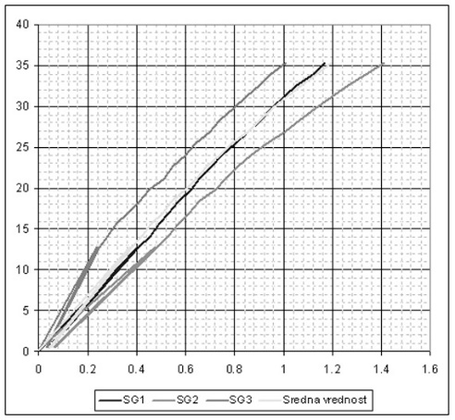 | 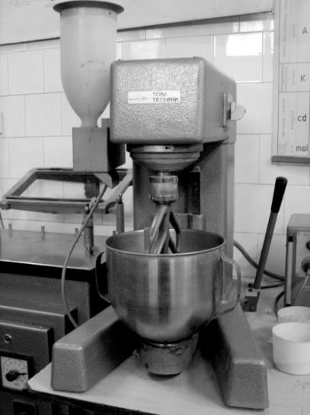
Fig. 1. Diagram | Fig. 2. B&W photograph

ACKNowledgements (optional heading style)
This optional heading should be inserted just before the References heading, both headings (Acknowledgements and References) being in bold Times New Roman 11 pt., without numbering.

REFERENCES
Please include references prepared according to instruction below, for example [1]. For citing the reference in the text use the number of the reference. Prepare a reference section listing all references in order of their citation in the text. For more than three authors use exp. Schmidt et al. For anonymous reports and standards, alphabetize by the issuing institution.
- Ceccotti A., Follesa M. (2006). Seismic Behaviour of Multi-Storey X-Lam Buildings. Proc. of COST E29 International Workshop on Earthquake Engineering on Timber Structures. Coimbra, Portugal, pp. 81-95.
- Follesa M. et al. (2015). A proposal for a new Background Document of Chapter 8 of Eurocode 8. Proc. of the International Network on Timber Engineering Research meeting INTER. Ŝibenik, Croatia, paper 48-102-1.
- European Committee for Standardization - CEN (2004). Eurocode 8 — Design of structures for earthquake resistance, Part 1: General rules, seismic actions and rules for buildings. Brussels, Belgium.
- Köhler J. (2007). Reliability of timber structures. PhD thesis. IBK ETH Zurich, Zurich, Switzerland.
- Gernay T., Franssen J.M. (2012). A formulation of Eurocode 2 concrete model at elevated temperature that includes an explicit term for transient creep. Fire Safety Journal vol. 51, pp. 1-9.

Position (Times New Roman 9pt.), Affiliation, City, Country, email@address1
Prof. PhD, Faculty of Civil Engineering, University “Ss. Cyril and Methodius”, Skopje, Republic of North Macedonia, user@gf.ukim.edu.mk

